ACSL
American Computer Science League
2013 - 2014

Contest #4

Classroom Division Solutions

- Data Structures
1. O and R

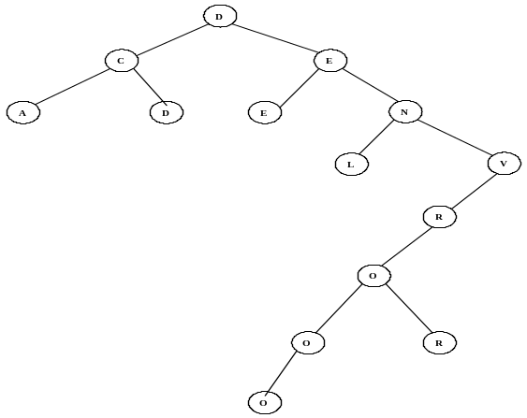

The binary tree formed is shown on the right.

2. Y
- Data Structures
The stack is constructed using LIFO as follows: R, RO, ROC, ROCK,
ROC, RO, ROY, ROYM, ROY, ROYT, ROYTN, ROYT, ROY. The next
element POPPED would be Y.
LO, O, OE, E, EH, EHS,HS. The next element POPPED is H.

3. Digital Electronics
The circuit translates to the Boolean expression: 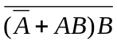
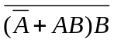=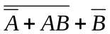= 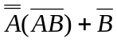= 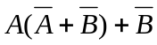=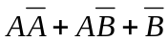= 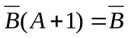

3. 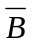

4. Digital Electronics
The circuit translates to: 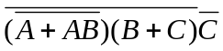

Note the first two factors may be commuted and the third may come first and the addends within the parentheses may be commuted.

4. 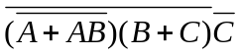

3 | 2 | 4 | 5 | 1
0 | 1 | 3 | 2 | 6
1 | 2 | 1 | 3 | 4

- What Does this Program Do?

The first loop looks for k’s and letters after m and puts them in b$.
It also looks for I’s and letters after w and puts them in c$.
The result is:b$ = “ktstssksnwvsownyrontostvs” and c$ = “iiyii”
d$ is the concatenation of b$ and c$.The next loop compares 2 letters at a
time and only places a letter in e$ if the first is alphabetically after the second
letter. It places the second letter in e$ resulting in “ssknvsonronosii”. The
last loop counts the number of n’s in e$. The answer is 3.

5. MIGCUCOAUTAI
5. 3

